Press Release: 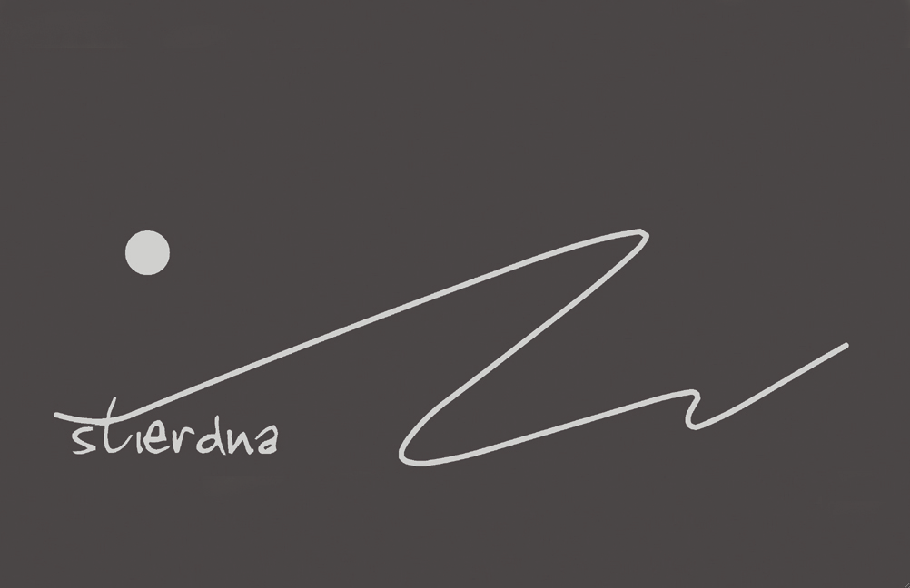
New CD
Mihkkala Joavnna Ánte Niillas – Anders Nils J. Eira / Niga
“Doalli”

Anders Nils J.Eira / Niga is born, raised and living in Maze. With this artist, we meet an experienced yoiker and actor. He has yoiked since childhood and has learned it since early. Anders Nils has performed and toured among others in Japan, Spain, throughout Scandinavia and Greenland.
He is what we call a traditional yoiker and in this release the material consists of both older and newer yoiks and self-composed. This recording is the second release and the first came out in 2001.
He is an accomplished yoiker and has a comfortable and expressive voice and rich in
ornament. With his deep bass voice, he shows maturity in the performance and the experience of his performance gives the listener the opportunity to immerse themselves in an old-fashioned world of tones and words that rarely can be described. On this recording we hear a yoik choir and here he brings guest yoikers from Maze, Karasjok and Kautokeino. For the first time in history, we hear a yoik choir where the performance reflects the tradition the way it once was in the old days. The experience of several voices simultaneously and in unison creates a new dimension in the vocal landscape where energies and ornaments meet in a timeless shift of phrase. This is to show a little of the old tradition where the Samis met in festive party and gatherings and where yoik was performed in unison by several people.
This CD is also an important document from Maze for the upcoming generation. On this recording we also meet a young guest yoiker from Karasjok named John Mathis Utsi.

The audience had to wait long for CD number 2 of this popular artist, but now it's finally here.

STI10 CD All rights reserved © & P 2015 STIERDNA, pb 95,N-9525 Máze
www.stierdna.com johansara@gmail.com Stierdna facebook RLabel
www.musikkoperatorene.no
Release: STIERDNA studio I Maze den 28.10.2015 kl.14:00 Welcome !
Artist contact: +47 959 63 035 – andersnilseira@yahoo.no - Producer: Johan Sara jr. +47 976 18383

Juoigan /Yoik Anders Nils J Eira
Guosse Juoigi John Mathis A.Utsi
Jouigan Kora Jan Ole Hermansen
Johan Mikkel J.Eira
Nils Jørgen Utsi
Lars Persen Gaup
John Mathis A.Utsi
Anders Nils J.Eira
Áittardeaddji/Producer Johan Sara jr.
Báddejuvvon ja miksejuvvon/
Recorded and mixed at: Tarragona/Spain and stiERdna studio
Maze by Johan Sara jr.
Masterbargu/Mastered at: Strype Audio by - Audun Strype
Govat/photos Marit Helene Eira
Cover hábmen/design Elisabeth Strifeldt

Red more about the artist at: stiERdna.com – Facebook – You Tube

